**Auto Reconciliation System Development**

**2022-12-01 by Harry**

1. **Objective**
2. **Preventing Financial incident by System or Human ( At least D+1)**
3. **Making Financial statement properly in Accounting**
4. **Saving Manpower Cost**
5. **Concept :**
6. **∑ Individual Customers’ Balance = Total Balance**
7. **Data in Core System = Data of Actual money**

**+**

**Transaction(D+1)**

**(Deposit /Withdrawal)**

**Closing Balance**

**(D+1)**

**Closing Balance**

**(D day)**

**=**

**c)**

1. **Process**

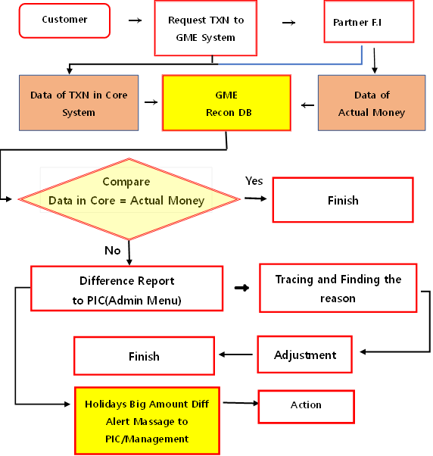

1. **Precondition for All Individual TXN**

**🡪**

**Previous Balance**

**(+)( -) TXN**

**Current Balance**

**+**

**<**

**=**

**0**

**a)**

1. **Failure Case of Auto debit for O.S Remittance 🡪 Changing Voucher**

**(Current) A/C574382 🡪 A/C345626 (After) A/C574382 + Wallet Update**

1. **Recon Cash deposit from all channels with voucher gernerated in Core System**

|  |  |  |  |  |  |  |
| --- | --- | --- | --- | --- | --- | --- |
| **Partner** | **Request** | **처리** | **Voucher**  **(1)** | **BankA/C**  **(2)** | **(2)-(1)** | **Report & Action** |
| **KFTC** | **해외송금** | **성공** | **(+)** | **(+)** | **0** | **No Action** |
|  | **해외송금** | **실패** | **(+)** | **(0)** | **-Diff** | **차액차감기표 /추심** |
|  | **해외송금** | **실패** | **(0)** | **(+)** | **+Diff** | **기표추가** |
|  | **국내이체** | **성공** | **(+)** | **(+)** | **0** | **No Action** |
|  | **국내이체** | **실패** | **(+)** | **(0)** | **-Diff** | **차액차감기표 /추심** |
|  | **국내이체** | **실패** | **(0)** | **(+)** | **+Diff** | **기표추가** |
|  | **Pay충전** | **성공** | **(+)** | **(+)** | **0** | **No Action** |
|  | **Pay충전** | **실패** | **(+)** | **(0)** | **-Diff** | **차액차감기표 /추심** |
|  | **Pay충전** | **실패** | **(0)** | **(+)** | **+Diff** | **기표추가** |
| **KJWallet** | **입금** | **성공** | **(+)** | **(+)** | **0** | **No Action** |
|  | **입금** | **실패** | **(+)** | **(0)** | **-Diff** | **차액차감기표 /추심** |
|  | **입금** | **실패** | **(0)** | **(+)** | **+Diff** | **기표추가** |
| **GLX-CVS** | **입금** | **성공** | **(+)** | **(+)** | **0** | **No Action** |
|  | **입금** | **실패** | **(+)** | **(0)** | **-Diff** | **차액차감기표 /추심** |
|  | **입금** | **실패** | **(0)** | **(+)** | **+Diff** | **기표추가** |
| **K7-ATM** | **입금** | **성공** | **(+)** | **(+)** | **0** | **No Action** |
|  | **입금** | **실패** | **(+)** | **(0)** | **-Diff** | **차액차감기표 /추심** |
|  | **입금** | **실패** | **(0)** | **(+)** | **+Diff** | **기표추가** |
| **KICC** | **입금** | **성공** | **(+)** | **(+)** | **0** | **No Action** |
|  | **입금** | **실패** | **(+)** | **(0)** | **-Diff** | **차액차감기표 /추심** |
|  | **입금** | **실패** | **(0)** | **(+)** | **+Diff** | **기표추가** |

1. **Recon Cash withdrawal(Deposit to Customers’ Bank account or Partners’ account) from all channels with voucher gernerated in Core System**

|  |  |  |  |  |  |  |
| --- | --- | --- | --- | --- | --- | --- |
| **Partner** | **Request** | **Result** | **Voucher**  **(1)** | **BankA/C**  **(2)** | **(2)-(1)** | **Remark** |
| **KFTC** | **Refund** | **성공** | **(-)** | **(-)** | **0** | **No Action** |
|  | **Refund** | **실패** | **(-)** | **(0)** | **Diff** | **차액차감기표 /추심** |
|  | **Refund** | **실패** | **(0)** | **(-)** | **Diff** | **기표추가** |
| **KFTC 등** | **국내이체** | **성공** | **(-)** | **(-)** | **0** | **No Action** |
|  | **국내이체** | **실패** | **(-)** | **(0)** | **Diff** | **차액차감기표 /추심** |
|  | **국내이체** | **실패** | **(0)** | **(-)** | **Diff** | **기표추가** |
| **KJ V/A** | **국내이체** | **성공** | **(-)** | **(-)** | **0** | **No Action** |
|  | **국내이체** | **실패** | **(-)** | **(0)** | **Diff** | **차액차감기표 /추심** |
|  | **국내이체** | **실패** | **(0)** | **(-)** | **Diff** | **기표추가** |
| **Coocon** | **출금** | **성공** | **(-)** | **(-)** | **0** | **No Action** |
|  | **출금** | **실패** | **(-)** | **(0)** | **Diff** | **차액차감기표 /추심** |
|  | **출금** | **실패** | **(0)** | **(-)** | **Diff** | **기표추가** |
| **K7-ATM** | **출금** | **성공** | **(-)** | **(-)** | **0** | **No Action** |
|  | **출금** | **실패** | **(-)** | **(0)** | **Diff** | **차액차감기표 /추심** |
|  | **출금** | **실패** | **(0)** | **(-)** | **Diff** | **기표추가** |

1. **Recon TXN not related directly with Cash(No change in Bank Acccount)**
2. **Wallet to Wallet(W🡪W)**
3. **Wallet to Overseas Remittance(OS Remit)**

|  |  |  |  |  |  |
| --- | --- | --- | --- | --- | --- |
| **Request** | **Result** | **Voucher(1)** | **Voucher(2)**  **Partners Statement** | **(1)+(2)** | **Action** |
| **W 🡪 W** | **S** | **Wallet(-)** | **Wallet(+)** | **0** |  |
|  | **F** | **Wallet(-)** | **Wallet(0)** | **-Diff** |  |
|  | **F** | **Wallet(0)** | **Wallet(+)** | **+Diff** |  |
| **OS Remit** | **S** | **Wallet(-)** | **Stock (-)** | **0** |  |
|  | **F** | **Wallet(-)** | **Stock (0)** | **Diff** |  |
|  | **F** | **Wallet(0)** | **Stock (-)** | **Diff** |  |

* **S=Success, F=Failure, W=Wallet**

**대사시스템 및 회계시스템 개선 뱡향**

1. **단계별적용 : 입금거래** 🡪 **출금거래** 🡪 **대체거래** 🡪 **해외거래**
2. **TXN Data in Core System = Inhouse Data( API )**
3. **거래유형별 은행계좌별 매치( CPA Recommendation)**
4. **시스템 부담 감축위해 Recon DB에 데이터 Batch방식으로 Upload 🡪**

**고객거래가 적은 새벽시간 활용(시스템 정비 위한 새벽시간 거래중단 제안)**

1. **Real Time Reconciliation 방식은** **시스템 과부하 초래로 향 후 개발 고려**
2. **과거 회계자료 변경 시 변경내용 보고서 출력(Admin) 및 적부 검토**
3. **해외파트너 밸런스 체킹시스템 개발(API)** 🡪 **SWIFT 혹은 Scrapping**
4. **1.을 제외한 자산 부채 비용 기타 더존=인하우스**
5. **결산시스템 Core – Inhouse – Douzone 연계 정비**